1.Connection of **MQ-135** gas sensor with Arduino uno

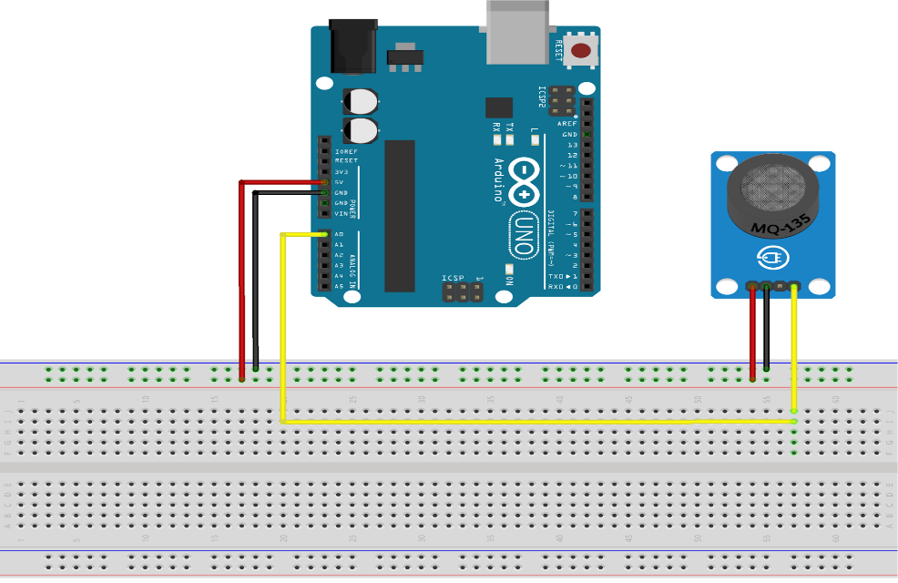

2. Connection of **MQ-7** gas sensors with Arduino uno

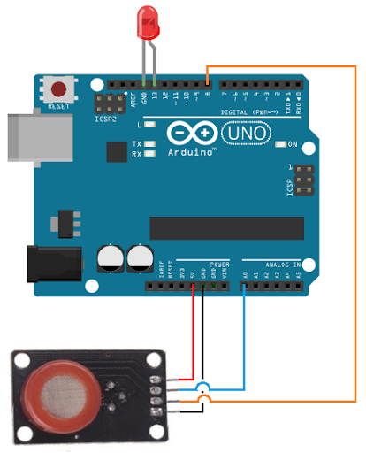

3.Connection of **MQ-2** gas sensor with Arduino uno

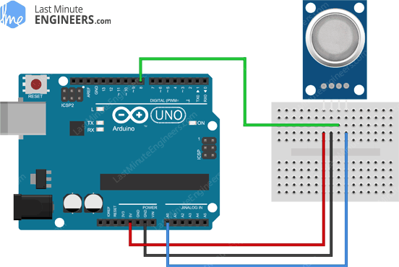

4. Connection of **PM2.5** particle sensor with Arduino uno

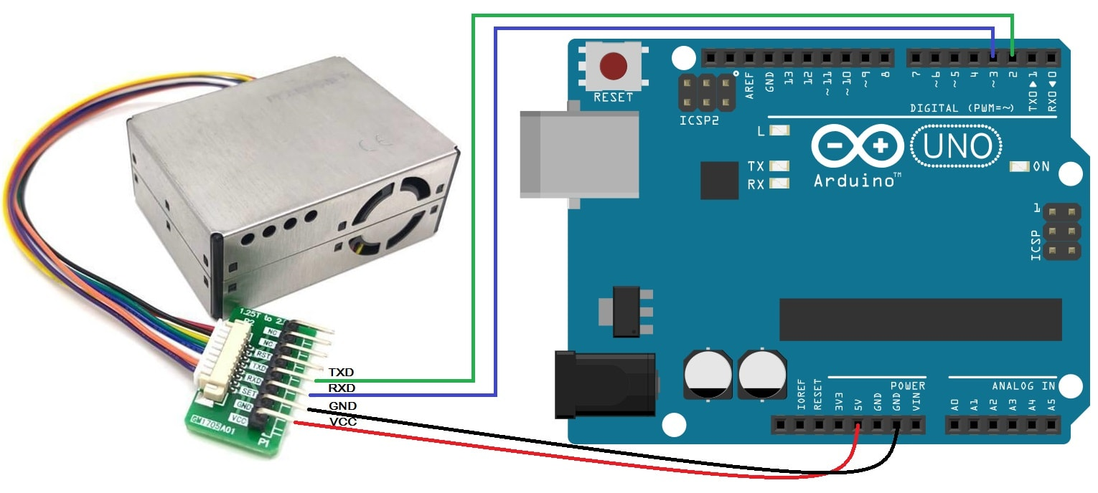

5. Connection of **PM10** particle sensor with Arduino uno

